**TP Regularización**

Enlace al repositorio: <https://github.com/mincaaccount/SSL-TP-Regulacion>

Análisis de lo requerido:

Expresión para usar: **ER [01]\.[0-9]?|[01]*B Centinela: #**

a = { 0,1 }

b = { . }

c = { 0, 1, 2, 3, 4, 5, 6, 7, 8, 9 }

d = {B}

**Regex:**

(a.(b+b.c))+(a*.d)

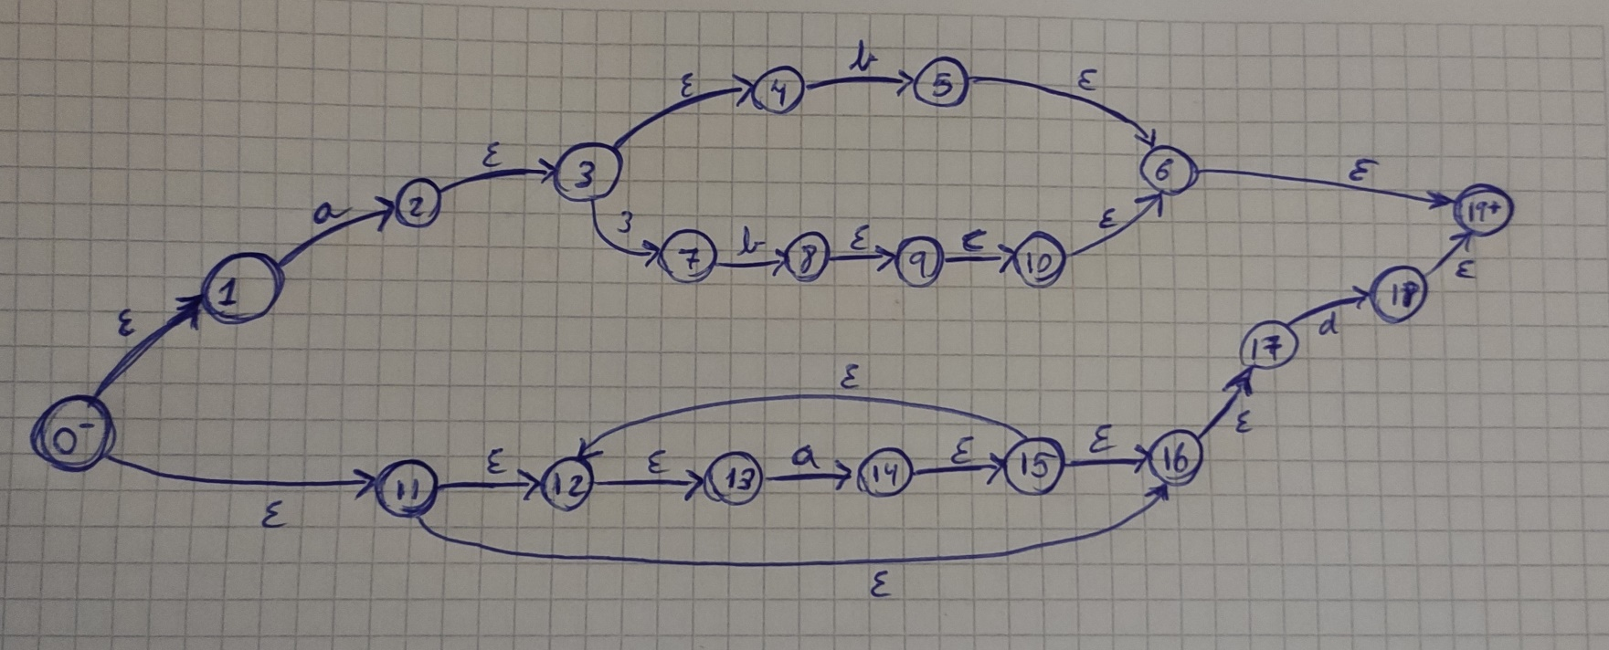Uso Thompson para obtener un AFN:

**AFN a AFD:**

|  |  |  |  |  |
| --- | --- | --- | --- | --- |
|  | a | b | c | d |
| {0, 1, 2, 3, 6, 7, 9} | {2, 3, 4, 5, 6, 7, 11, 12, 14} | - | - | {8, 19} |
| {2, 3, 4, 5, 6, 7, 11, 12, 14} | {2, 3, 4, 5, 6, 7} | {13, 15, 16, 18, 19} | - | {8, 19} |
| {2, 3, 4, 5, 6, 7} | {2, 3, 4, 5, 6, 7} | - | - | {8, 19} |
| {13, 15, 16, 18, 19} | - | - | {18, 19} | - |
| {8, 19} | - | - | - | - |
| {18, 19} | - | - | - | - |

0 = {0, 1, 2, 3, 6, 7, 9}

1 = {2, 3, 4, 5, 6, 7, 11, 12, 14}

2 = {2, 3, 4, 5, 6, 7}

3 = {13, 15, 16, 18, 19}

4 = {8, 19}

5 = {18, 19}

|  |  |  |  |  |
| --- | --- | --- | --- | --- |
|  | **a** | **b** | **c** | **d** |
| **0-** | 1 | - | - | 4 |
| **1** | 2 | 3 | - | 4 |
| **2** | 2 | - | - | 4 |
| **3+** | - | - | 5 | - |
| **4+** | - | - | - | - |
| **5+** | - | - | - | - |

ADF Inicial:

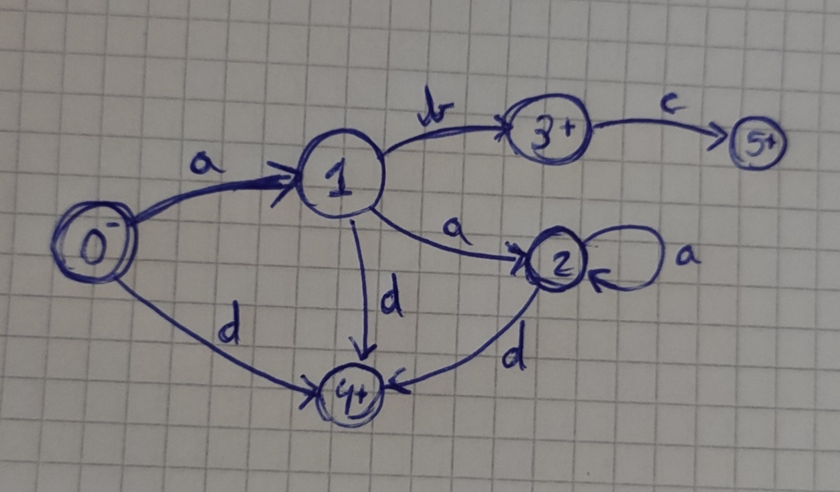

Busco ADF Mínimo:

|  |  |  |  |  |  |
| --- | --- | --- | --- | --- | --- |
|  | **a** | **b** | **c** | **d** | **Clase** |
| **0-** | 1 | - | - | 4 | C0 |
| **1** | 2 | 3 | - | 4 | C0 |
| **2** | 2 | - | - | 4 | C0 |
| **3+** | - | - | 5 | - | C1 |
| **4+** | - | - | - | - | C1 |
| **5+** | - | - | - | - | C1 |

4 y 5 son equivalentes:

|  |  |  |  |  |  |
| --- | --- | --- | --- | --- | --- |
|  | **a** | **b** | **c** | **d** | **Clase** |
| **0-** | 1 | - | - | 4 | C0 |
| **1** | 2 | 3 | - | 4 | C0 |
| **2** | 2 | - | - | 4 | C0 |
| **3+** | - | - | 4 | - | C1 |
| **4+** | - | - | - | - | C1 |

Nueva Tabla:

|  |  |  |  |  |  |
| --- | --- | --- | --- | --- | --- |
|  | **a** | **b** | **c** | **d** | **Clase** |
| **0-** | C0 | - | - | C1 | C2 |
| **1** | C0 | C1 | - | C1 | C0 |
| **2** | C0 | - | - | C1 | C2 |
| **3+** | - | - | C1 | - | C1 |
| **4+** | - | - | - | - | C3 |

|  |  |  |  |  |  |
| --- | --- | --- | --- | --- | --- |
|  | **a** | **b** | **c** | **d** | **Clase** |
| **0-** | C0 | - | - | C3 | C2 |
| **1** | C2 | C1 | - | C3 | C0 |
| **2** | C2 | - | - | C3 | C2 |
| **3+** | - | - | C3 | - | C1 |
| **4+** | - | - | - | - | C3 |

AFD Mínimo:

|  |  |  |  |  |
| --- | --- | --- | --- | --- |
|  | **a** | **b** | **c** | **d** |
| **0-** | 1 | - | - | 4 |
| **1** | 2 | 3 | - | 4 |
| **2** | 2 | - | - | 4 |
| **3+** | - | - | 4 | - |
| **4+** | - | - | - | - |

